1. 서언 (부르심 / 자기희생)
Theme: 따르라 / 생명을 버림

1. Christ as the Man of Sorrows - Petrus Christus
정면 응시, 극도로 집중된 고통
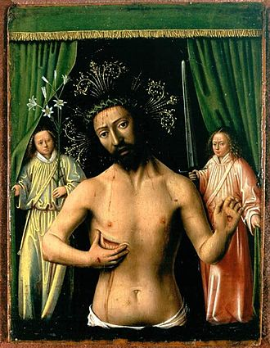
Source: https://commons.wikimedia.org/wiki/File:Petrus_christus%2C_cristo_dolente.jpg

2. Head of Christ - Rembrandt
얼굴 중심, 빛 하나로 표현

Image could not be resolved.

3. Christ Carrying the Cross - El Greco (horizontal version)
이미 고난을 향하는 방향성

Image could not be resolved.

4. The Light of the World - William Holman Hunt
어둠 속 빛 (도입용 최적)

Image could not be resolved.

5. Christ Blessing - Antonello da Messina
정면 클로즈업, 매우 강력
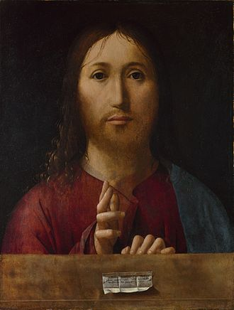
Source: https://commons.wikimedia.org/wiki/File:Antonello_da_Messina_061.jpg

2. 유월절 준비 (배반 예고)
Theme: 긴장 / 정적 / 불안

1. Supper at Emmaus - Caravaggio (1601)
2~3명 중심, 어두운 배경
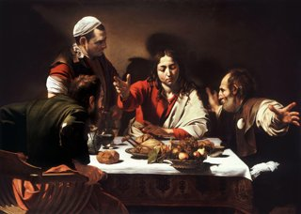
Source: https://commons.wikimedia.org/wiki/File:Supper_at_Emmaus-Caravaggio_(1601).jpg

2. Supper at Emmaus - Caravaggio (1606, darker version)
테네브레 더 강함

Image could not be resolved.

3. Last Supper (detail crop 추천) - Leonardo da Vinci
얼굴 중심으로 자르면 완벽

Image could not be resolved.

4. Christ at Table - Georges de La Tour (candlelight)
촛불 + 어둠 = 테네브레 핵심

Image could not be resolved.

5. The Last Supper - Philippe de Champaigne
정적, 인물 적음
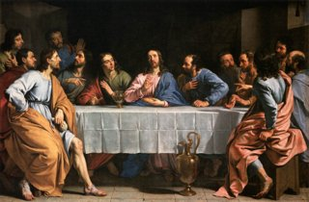
Source: https://commons.wikimedia.org/wiki/File:Philippe_de_Champaigne_-_The_Last_Supper_-_WGA4710.jpg

3. 발 씻기심 (섬김)
Theme: 낮아짐 / 관계

1. Christ Washing Peters Feet - Ford Madox Brown
이미 최적
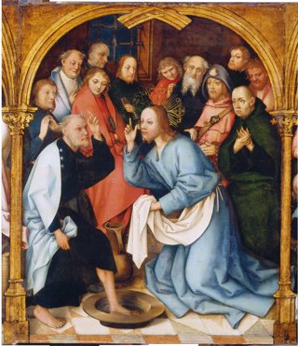
Source: https://commons.wikimedia.org/wiki/File:Christ_Washing_St_Peter%27s_Feet_(SM_hm19).png

2. Washing of the Feet - Caravaggio 계열 (tenebrism 스타일)
강한 명암
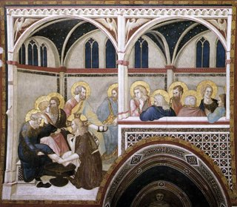
Source: https://commons.wikimedia.org/wiki/File:Pietro_Lorenzetti_-_The_Washing_of_the_Feet_-_WGA13506.jpg

3. Christ Washing Feet - Harold Copping
감정 전달 탁월
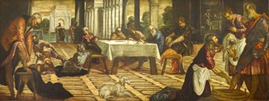
Source: https://commons.wikimedia.org/wiki/File:Tintoretto_Christ_washing_feet_Ontario.jpg

4. Washing of the Feet - Duccio (detail crop 추천)
인물만 잘라 쓰기 좋음
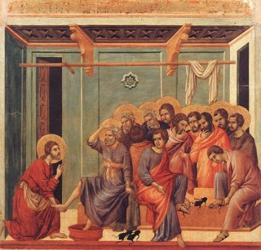
Source: https://commons.wikimedia.org/wiki/File:Washing_of_the_Feet.jpg

5. Christ and Peter - 현대 realist 계열 (low light composition)
실제 예배 화면에서 효과 좋음
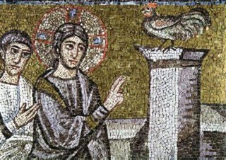
Source: https://commons.wikimedia.org/wiki/File:Apollinare_Nuovo_Christ_Peter_and_Peter_s_Denial.jpg

4. 최후의 만찬 (성찬)
Theme: 몸과 피 / 언약

1. The Sacrament of the Last Supper - Salvador Dalí
가로 + 집중 + 상징 완벽
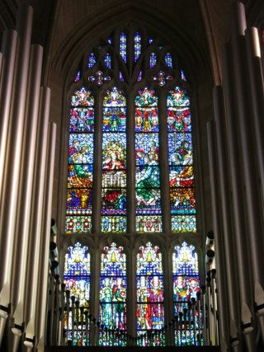
Source: https://commons.wikimedia.org/wiki/File:Cathedral_of_the_Most_Blessed_Sacrament_(Detroit%2C_Michigan)_-_stained_glass%2C_The_Last_Supper.JPG

2. Last Supper - Tintoretto (1592, dark version)
빛이 한쪽에서만 들어옴

Image could not be resolved.

3. Supper at Emmaus - Caravaggio (재활용 가능)
성찬 장면으로 매우 좋음

Image could not be resolved.

4. Last Supper - Rembrandt (light focus)
얼굴 중심
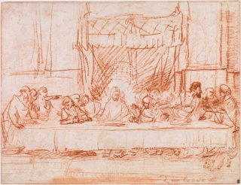
Source: https://commons.wikimedia.org/wiki/File:The_Last_Supper%2C_after_Leonardo_da_Vinci_by_Rembrandt_01.jpg

5. Candlelit Supper - Georges de La Tour 계열
촛불 테네브레 핵심
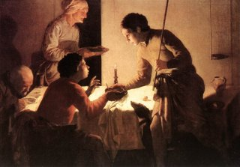
Source: https://commons.wikimedia.org/wiki/File:Hendrick_ter_Brugghen_-_The_Supper_-_WGA22170.jpg

5. 겟세마네 (고뇌)
Theme: 완전한 고독

1. Christ in Gethsemane - Henry Ossawa Tanner
이건 무조건 써야 함
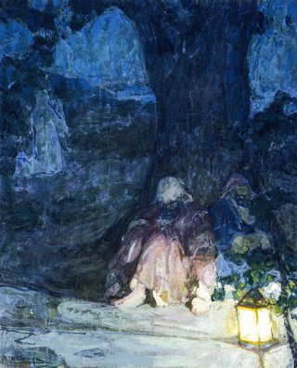
Source: https://commons.wikimedia.org/wiki/File:The_Sleeping_Disciples%2C_Henry_Ossawa_Tanner.jpg

2. Christ in Gethsemane - Carl Bloch
감정 직관적
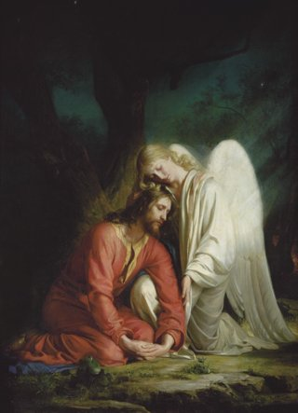
Source: https://commons.wikimedia.org/wiki/File:%27Christ_in_Gethsemane%27_by_Carl_Heinrich_Bloch%2C_1880.jpg

3. Agony in the Garden - El Greco (tight crop)
배경 제거하면 최고
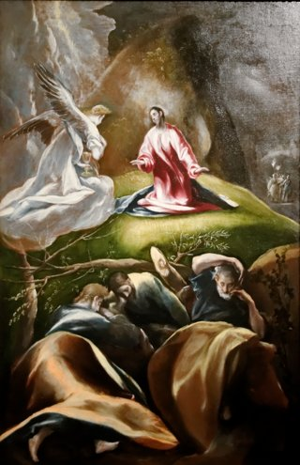
Source: https://commons.wikimedia.org/wiki/File:Agony_in_the_garden_El_Greco.jpg

4. Christ Praying - Rembrandt (etching 계열)
빛/어둠 대비
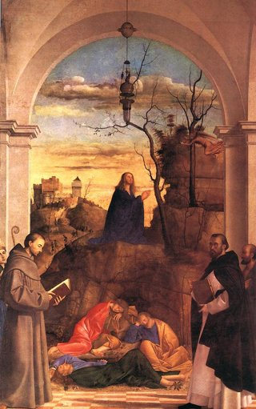
Source: https://commons.wikimedia.org/wiki/File:Christ_Praying_in_the_Garden.jpg

5. Christ Alone in Prayer - modern chiaroscuro works
실제 예배용 강력
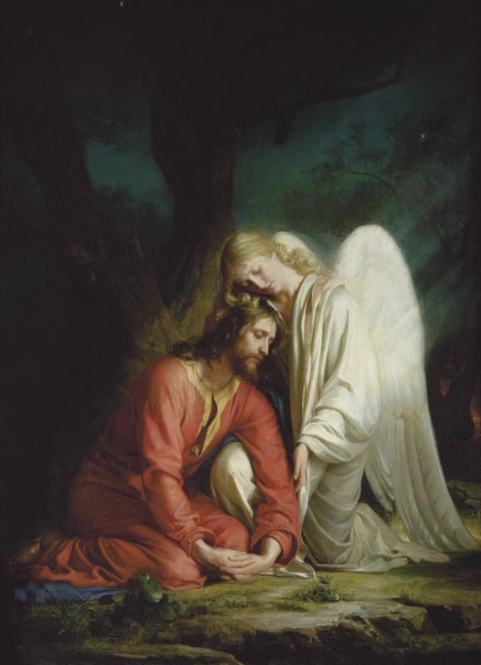
Source:

6. 체포 (배신)
Theme: 충격 / 밀착

1. The Taking of Christ - Caravaggio (1602)
이건 거의 필수
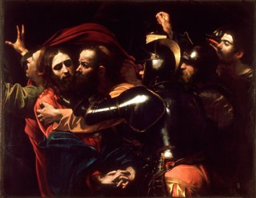
Source: https://commons.wikimedia.org/wiki/File:The_Taking_of_Christ-Caravaggio_(c.1602).jpg

2. The Kiss of Judas - Giotto (tight crop)
얼굴만 쓰면 좋음

Image could not be resolved.

3. Betrayal of Christ - Gustave Doré (close composition)
강렬
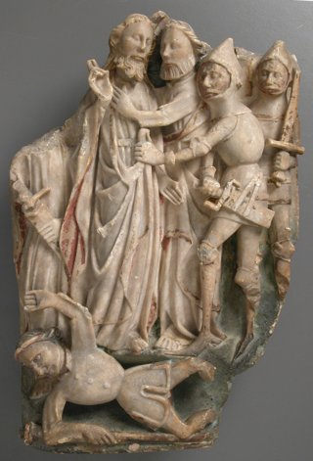
Source: https://commons.wikimedia.org/wiki/File:The_Betrayal_of_Christ_MET_sf1980-476s1.jpg

4. Arrest of Christ - Rembrandt school
어둠 강조
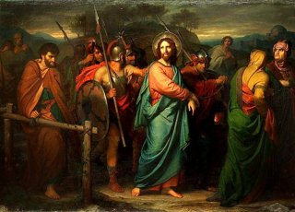
Source: https://commons.wikimedia.org/wiki/File:Hofmann%2C_Arrest_of_Christ_1858.jpg

5. Betrayal Scene - modern chiaroscuro painting
실전 영상용 느낌
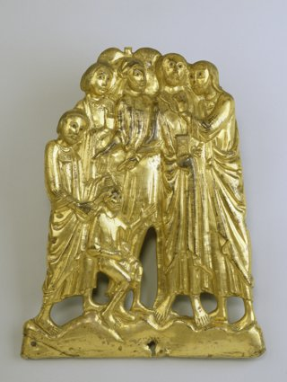
Source: https://commons.wikimedia.org/wiki/File:French_-_The_Betrayal_of_Christ_-_Walters_5310.jpg

7. 베드로 / 유다
Theme: 죄책감 / 붕괴

1. The Denial of Saint Peter - Caravaggio (1610)
완벽 (3명 구성)
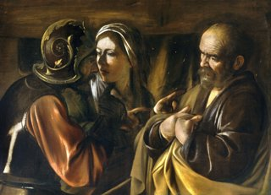
Source: https://commons.wikimedia.org/wiki/File:The_Denial_of_Saint_Peter-Caravaggio_(1610).jpg

2. Denial of Peter - Rembrandt
감정 깊음
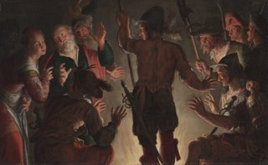
Source: https://commons.wikimedia.org/wiki/File:Peter_Wtewael_-_The_Denial_of_Peter_-_1972.169_-_Cleveland_Museum_of_Art.tiff

3. Saint Peter Weeping - El Greco
개인 묵상 최고

Image could not be resolved.

4. Judas Repentance - Tissot (crop 추천)
유다 강조

Image could not be resolved.

5. Man of Sorrows - Petrus Christus
죄의 결과 묵상 연결

Image could not be resolved.

8. 빌라도 (재판)
Theme: 진리 vs 침묵

1. Christ before Pilate - Munkácsy (crop 추천)
얼굴 중심으로 자르면 최고
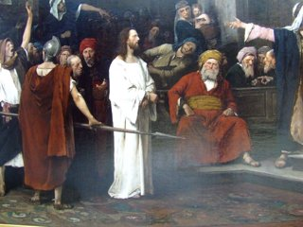
Source: https://commons.wikimedia.org/wiki/File:Munk%C3%A1csy_Christ_before_Pilate_part1.JPG

2. Ecce Homo - Caravaggio 계열
얼굴 클로즈업
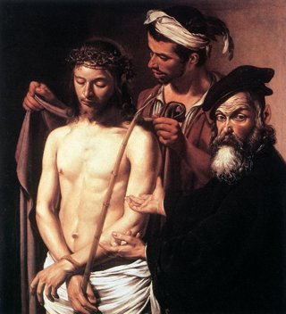
Source: https://commons.wikimedia.org/wiki/File:Caravaggio_Ecce_Homo.jpg

3. Christ before Pilate - Gérôme (tight crop)
현실감
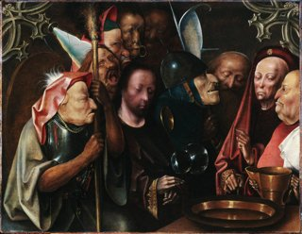
Source: https://commons.wikimedia.org/wiki/File:Bosch_follower_Christ_Before_Pilate_(Princeton).jpg

4. Mocking of Christ - Cimabue (crop)
고통 강조
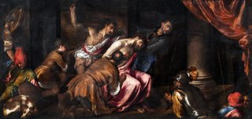
Source: https://commons.wikimedia.org/wiki/File:(Venice)_The_Mocking_of_Christ_by_Jacopo_Da_ponte_-_gallerie_Accademia_Venice.jpg

5. Ecce Homo - Ribera (tenebrism)
어둠 매우 강함

Image could not be resolved.

9. 십자가
Theme: 고통 / 구속

1. Crucifixion - Grünewald (Isenheim)
가장 강력

Image could not be resolved.

2. Christ of Saint John of the Cross - Dalí
가로 구성 완벽
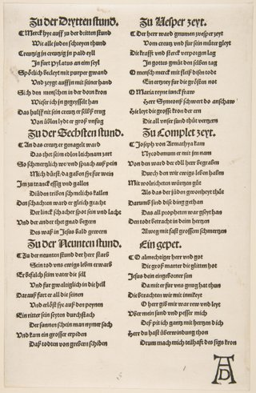
Source: https://commons.wikimedia.org/wiki/File:Christ_on_the_Cross_with_Mary_and_Saint_John_(second_sheet_of_two)_MET_DP816068.jpg

3. The Three Crosses - Rembrandt
빛/어둠 극대화
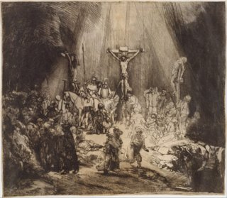
Source: https://commons.wikimedia.org/wiki/File:Christ_Crucified_between_the_Two_Thieves-_The_Three_Crosses_MET_DT11821.jpg

4. Crucifixion - Velázquez
고요 + 집중
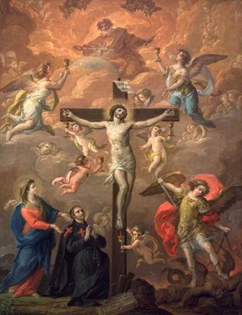
Source: https://commons.wikimedia.org/wiki/File:Antonio_Gonz%C3%A1lez_Vel%C3%A1zquez_-_Crucifixion_with_St_Michael_-_WGA9746.jpg

5. Crucifixion - Ribera
어둠 극단적
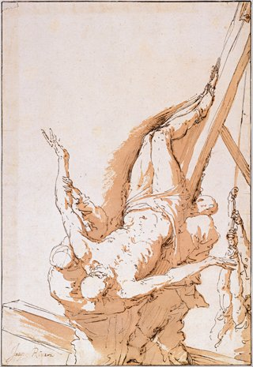
Source: https://commons.wikimedia.org/wiki/File:Jusepe_de_Ribera_-_Crucifixion_of_Saint_Peter%2C_c.1625-1630_-_Google_Art_Project.jpg

10. 일곱 말씀 (완성 / 침묵)
Theme: 완전한 어둠

1. The Entombment of Christ - Caravaggio (160304)
마지막 장면 최고

Image could not be resolved.

2. Entombment - El Greco
어둠 + 감정

Image could not be resolved.

3. Dead Christ - Mantegna (horizontal)
시선 집중
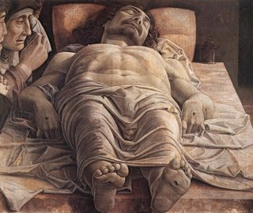
Source: https://commons.wikimedia.org/wiki/File:Mantegna_Andrea_Dead_Christ.jpg

4. Pietà - Michelangelo (crop 가능)
감정 깊이

Image could not be resolved.

5. Entombment - Luca Giordano
구도 안정

Image could not be resolved.

